Test document

USAID template

Dan Killian

# Heading 1

## Heading 2

### Heading 3

### Heading 4

#### This is a test

This is a test of a Quarto document that is saved in MS Word and should look like a USAID-formatted document.

In using Quarto to export to Word, the idea is that we would post only formatted tables and figures. Accordingly, the global options sets echo = F such that any calculations are hidden and we only see the output. So if we do a simple calculation of 2+2, we won’t see the code box executing that calculation.

[1] 4

From a report standpoint, we don’t want to do that. Rather, we just want finished tables and figures. Here’s a table.

| mpg | cyl | disp | hp | drat | wt |
| --- | --- | --- | --- | --- | --- |
| 21.0 | 6 | 160 | 110 | 3.90 | 2.620 |
| 21.0 | 6 | 160 | 110 | 3.90 | 2.875 |
| 22.8 | 4 | 108 | 93 | 3.85 | 2.320 |
| 21.4 | 6 | 258 | 110 | 3.08 | 3.215 |
| 18.7 | 8 | 360 | 175 | 3.15 | 3.440 |

This is flextable. I normally use gt but that doesn’t support exporting to Word just yet.

And a figure.

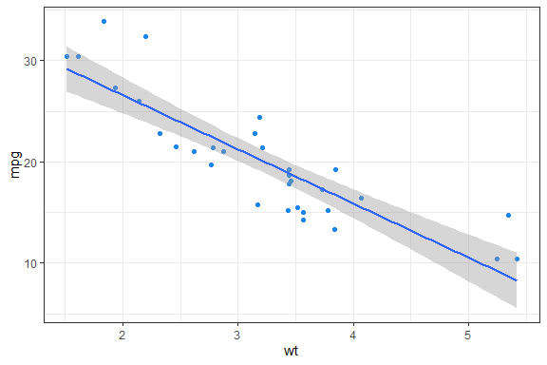

And a diagram.

However, this is html and does not render to Word. Instead we can save the diagram and call the picture.

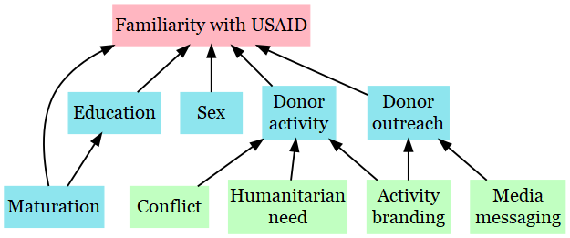

Of course, we’ll want to use Adam Bloom’s dolled up version of a diagram we might create.

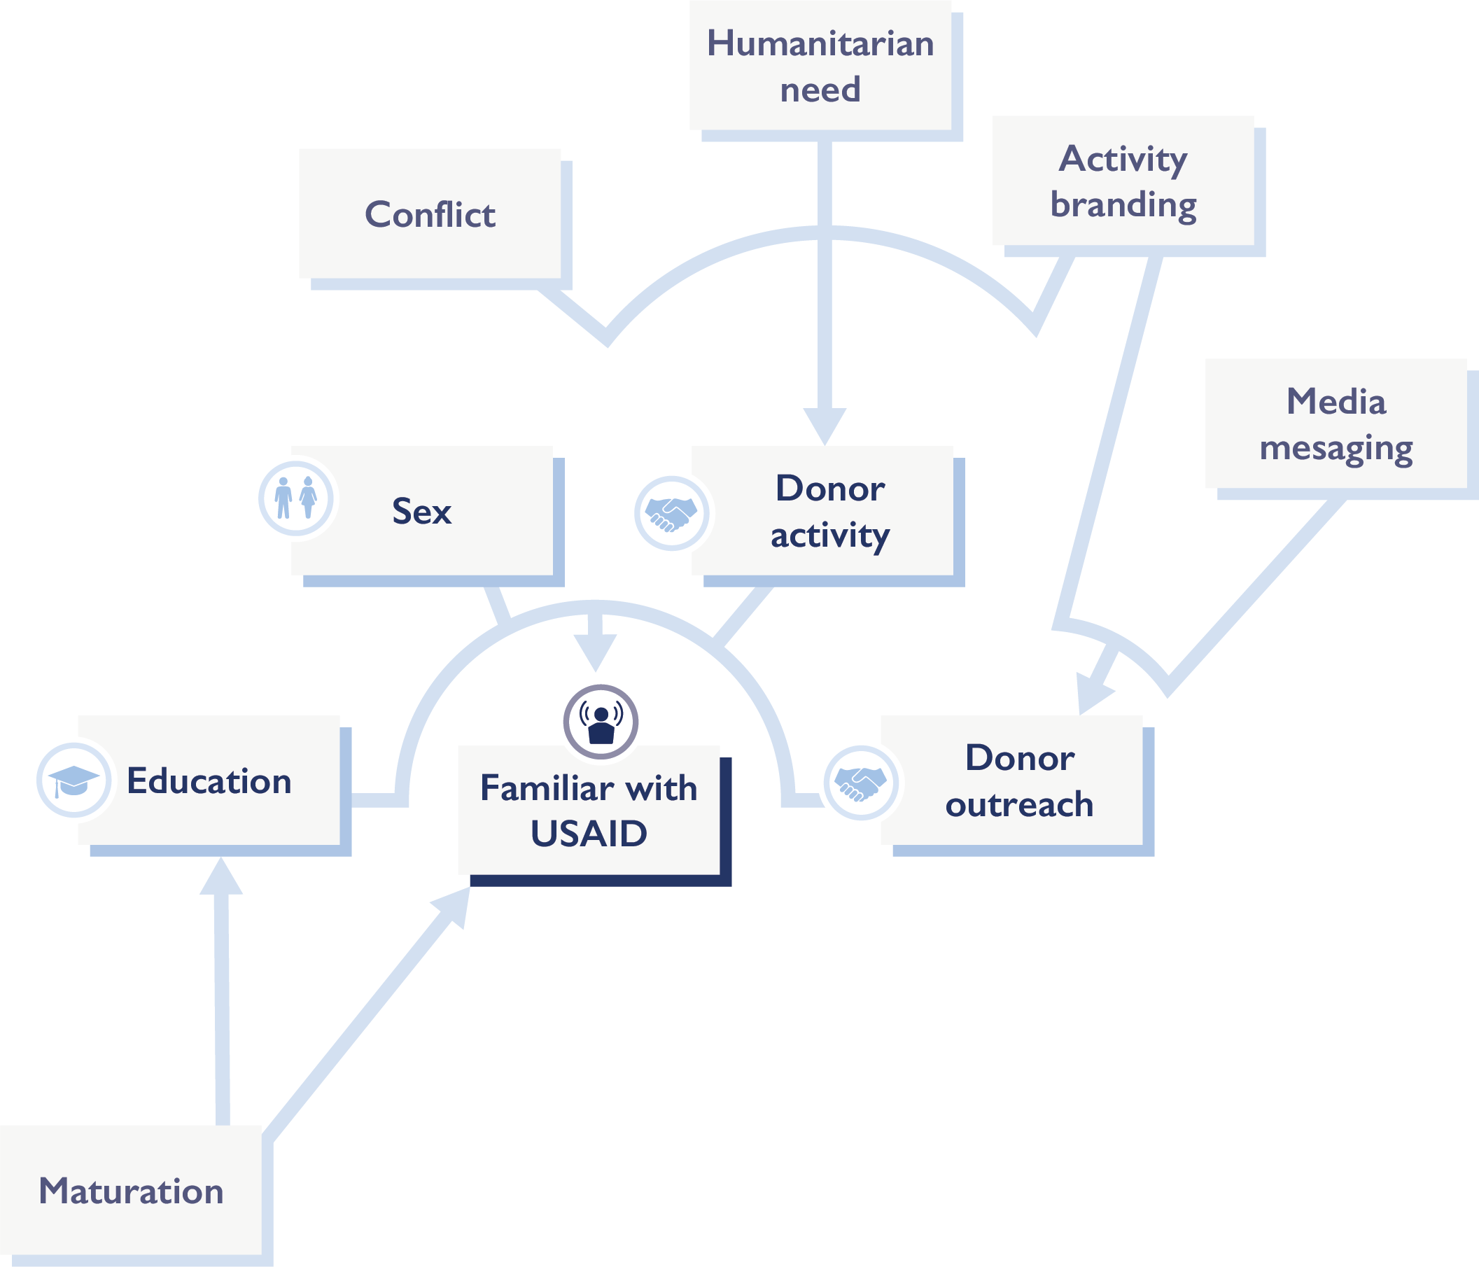

Let’s see if this Quarto to Word pipeline ends up having some applications at MSI.

Finis!